Protein Synthesis Review - Answer Key
1. Label Diagram A (on the back)
A | DNA | F | Codon | K | tRNA
B | RNA Polymerase | G | Amino acids | L | Proteins
C | mRNA | H | rRNA | M | RNA nucleotides
D | Nuclear membrane | I | Anticodon | 1. | Transcription
E | mRNA | J | Polypeptide chain | 2. | Translation
2. Given the following ORIGINAL DNA nucleotide sequence CCA GCT ATG
A. Give the complementary DNA sequence to the above strand
GGT CGA TAC

B. Give the mRNA codons that would be transcribed using the ORIGINAL strand of DNA.
GGU CGA UAG

C. Give the tRNA anticodons.
CCA GCU AUG

D. Give the amino acid sequence that would be translated from it.
Glycine – Arginine - STOP

3. Given the following ORIGINAL DNA nucleotide sequence TTG CGA GTC
A. Give the complementary DNA sequence to the above strand
AAC GCT CAG

B. Give the mRNA codons that would be transcribed using the COMPLEMENTARY strand of DNA.
UUG CGA GUC

C. Give the tRNA anticodons.
AAC GCU CAG

D. Give the amino acid sequence that would be translated from it.
Leucine-Arginine-Valine

4. GIven the following amino acid sequence, give a possible DNA sequence that could code for the sequence Serine Histidine Valine
There are many answers to this question, but the key is to first find a mRNA sequence that works:
Example 1. UCU CAU GUU Example 2. AGU CAC GUC
Then use this sequence to find the DNA sequence:
Example 1. AGA GTA CAA Example 2. TCA GTG CAG

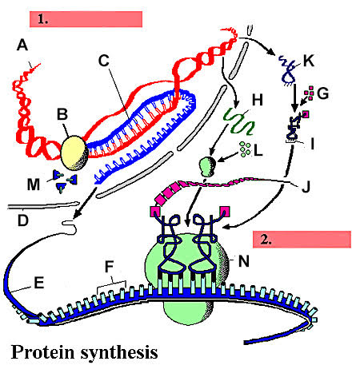

Protein Synthesis Review
1. Label Diagram A (on the back)
A |  | F |  | K
B |  | G |  | L
C |  | H |  | M
D |  | I |  | 1.
E |  | J |  | 2.
2. Given the following ORIGINAL DNA nucleotide sequence CCA GCT ATG
A. Give the complementary DNA sequence to the above strand

B. Give the mRNA codons that would be transcribed using the ORIGINAL strand of DNA.

C. Give the tRNA anticodons.

D. Give the amino acid sequence that would be translated from it.

3. Given the following ORIGINAL DNA nucleotide sequence TTG CGA GTC
A. Give the complementary DNA sequence to the above strand

B. Give the mRNA codons that would be transcribed using the COMPLEMENTARY strand of DNA.

C. Give the tRNA anticodons.

D. Give the amino acid sequence that would be translated from it.

3. GIven the following amino acid sequence, give a possible DNA sequence that could code for the sequence Serine Histidine Valine

